**Beginning Note:** This guide is essentially the same as installing TWRP on the Axon 7, as published [here](https://forum.xda-developers.com/axon-7-mini/development/unlock-tuliptool-unlock-twrp-custom-boot-t3682781). The only real difference is the name and limitations of JasmineTool v TulipTool. Make sure your K88 is on Android 7.1.1, I just used the over the air (OTA) update. These screenshots may not match the versions of the files you send to the tablet. I’m not going to update them every time a new build gets released. Also I’m not responsible for how things work out. Every time you see this on XDA, I would appreciate if you give user wgeorgecook a thanks!

**Step 1: Download and install ADB**

Before we begin, we need to make sure that the Android Debugging Bridge is installed. This is how I like to have it for simplicity. You can install the tools however you want, but I’m assuming you’re set up like me. Download the ADB tools folder and extract the contents to C:\adb as this:

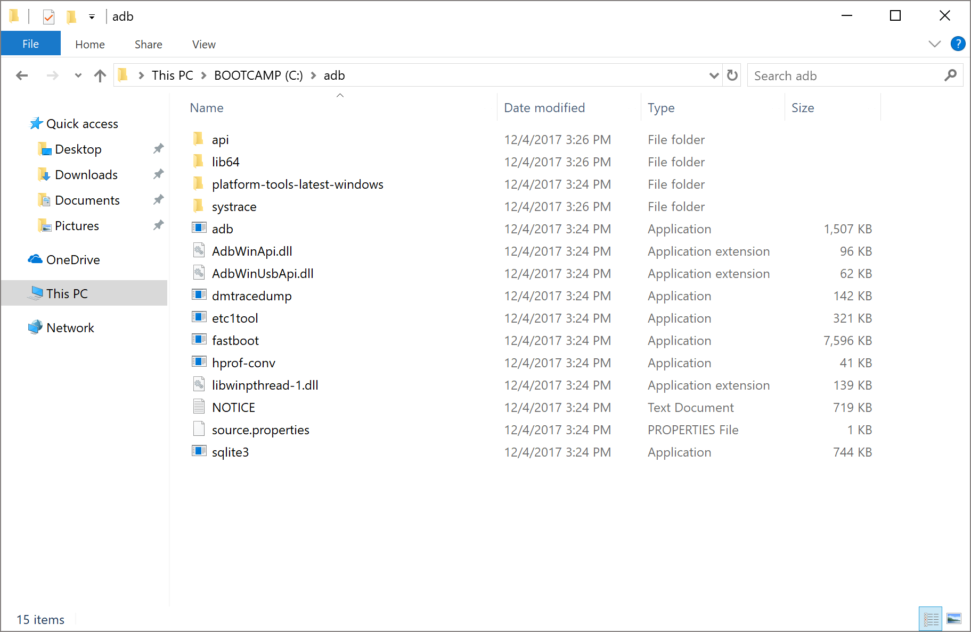

If you don’t configure the environment variable as below, you’ll need to run the ADB commands from C:\adb

**Step 1.2 (OPTIONAL): Configure Environment variable for ADB**

Establishing the environment variable will let you use the ADB command from anywhere and not just in C:\adb. Hit the Windows key and search for “Environment Variables”. Click the “Edit the system environment variables” and it opens up this window - click Environment Variables.

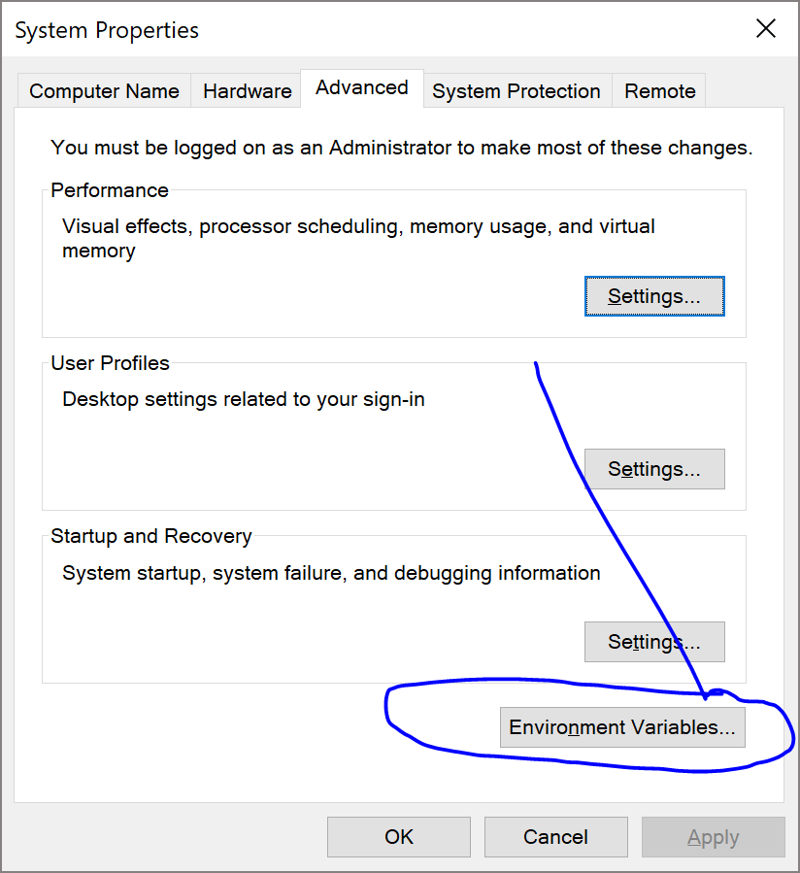

Add a new line such as this:

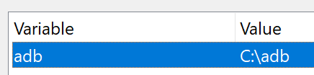

**Step 2: Enabling Developer Options on the tablet**

Tablet side, we need to make sure Developer Options are unlocked. I’m not going to screenshot and transfer tablet stuff, so just follow along with [this guide](https://www.digitaltrends.com/mobile/how-to-get-developer-options-on-android/). Go into your new Developer Options menu and enable USB Debugging.

**Step 3: Install tablet drivers and download utilities**

To make sure you’re up to speed and ready to begin, fire up the terminal and type in *adb devices*. You should see the server start and your tablet listed. If so, issue an *adb reboot edl* command.

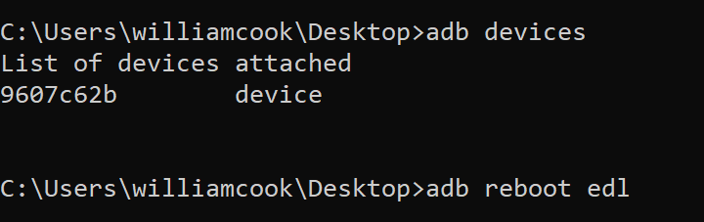

We’re ready to start getting the goods onto our tablet now. Head over to <http://zadig.akeo.ie/> and download Zadig. To get my device to show up, I needed to go into the Options menu and Show all devices. Mine showed up as this funky device, but make sure your USB ID is 05C69008. Have Zadig install the WinUSB driver and when it completes, manually reboot your tablet.

Run *adb devices* to check that your tablet is connected and then issue another *adb reboot edl* command. Now we need the JasmineTool. Grab jasminetool.zip and jasmine-twrp-7.1-r3.img from <http://files.nwwn.com/android/k88/>. I extract the zip to the desktop and put the image file there too for simplicity. Others on XDA suggest putting it in C:\adb so everything is in one place. Open your terminal and navigate to jasminetool folder.

**Step 4: Flash recovery**

Jasminetool is a command line only tool that can read and write to the recovery and boot partitions. Use *jasminetool-win64.exe read recovery* to verify that you’re connected to the tablet and that Jasminetool can talk to it:

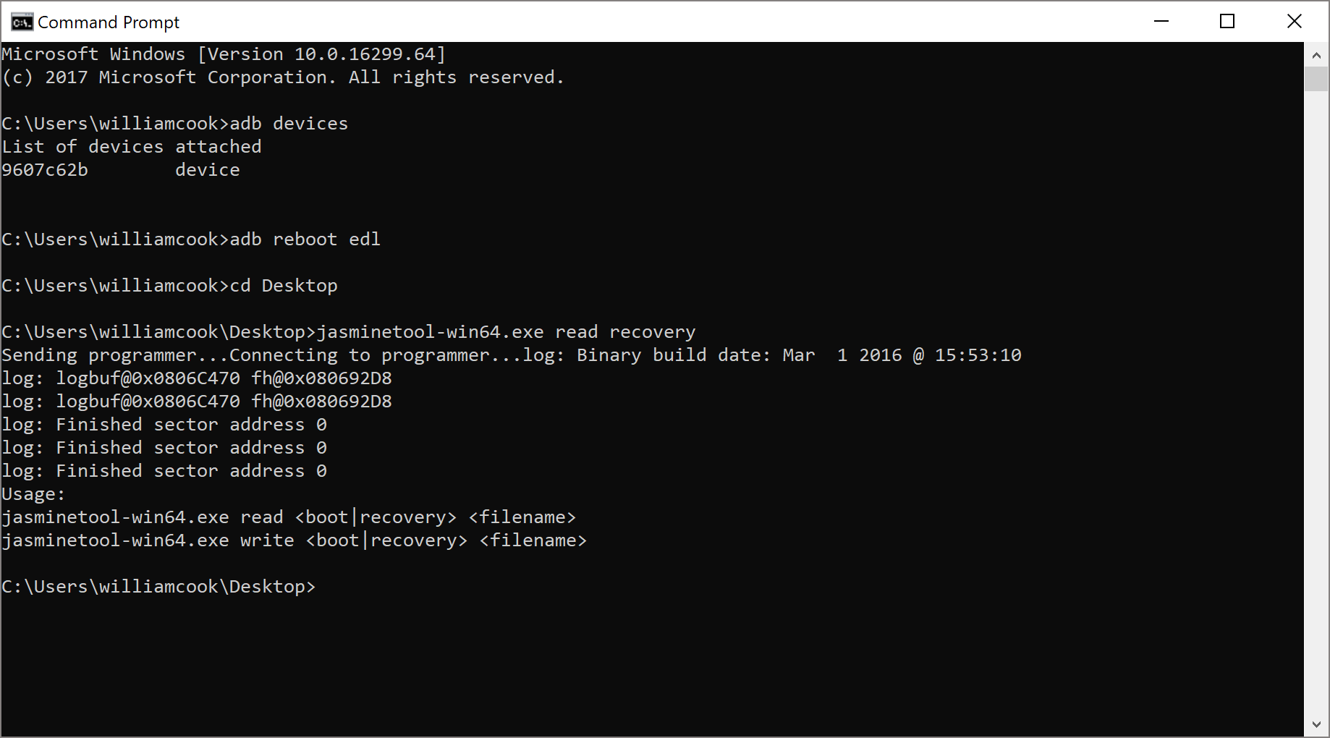

If that command didn’t error out, give your tablet a reboot and reenter EDL mode. Now for the scary part. Send *jasminetool-win64.exe write recovery jasmine-twrp-7.1-r3.img* to the tablet. It’s going to tell you all sorts of things and ask that you explicitly write “I AGREE” before proceeding. After it completes it will cool down for five seconds and reboot your tablet:

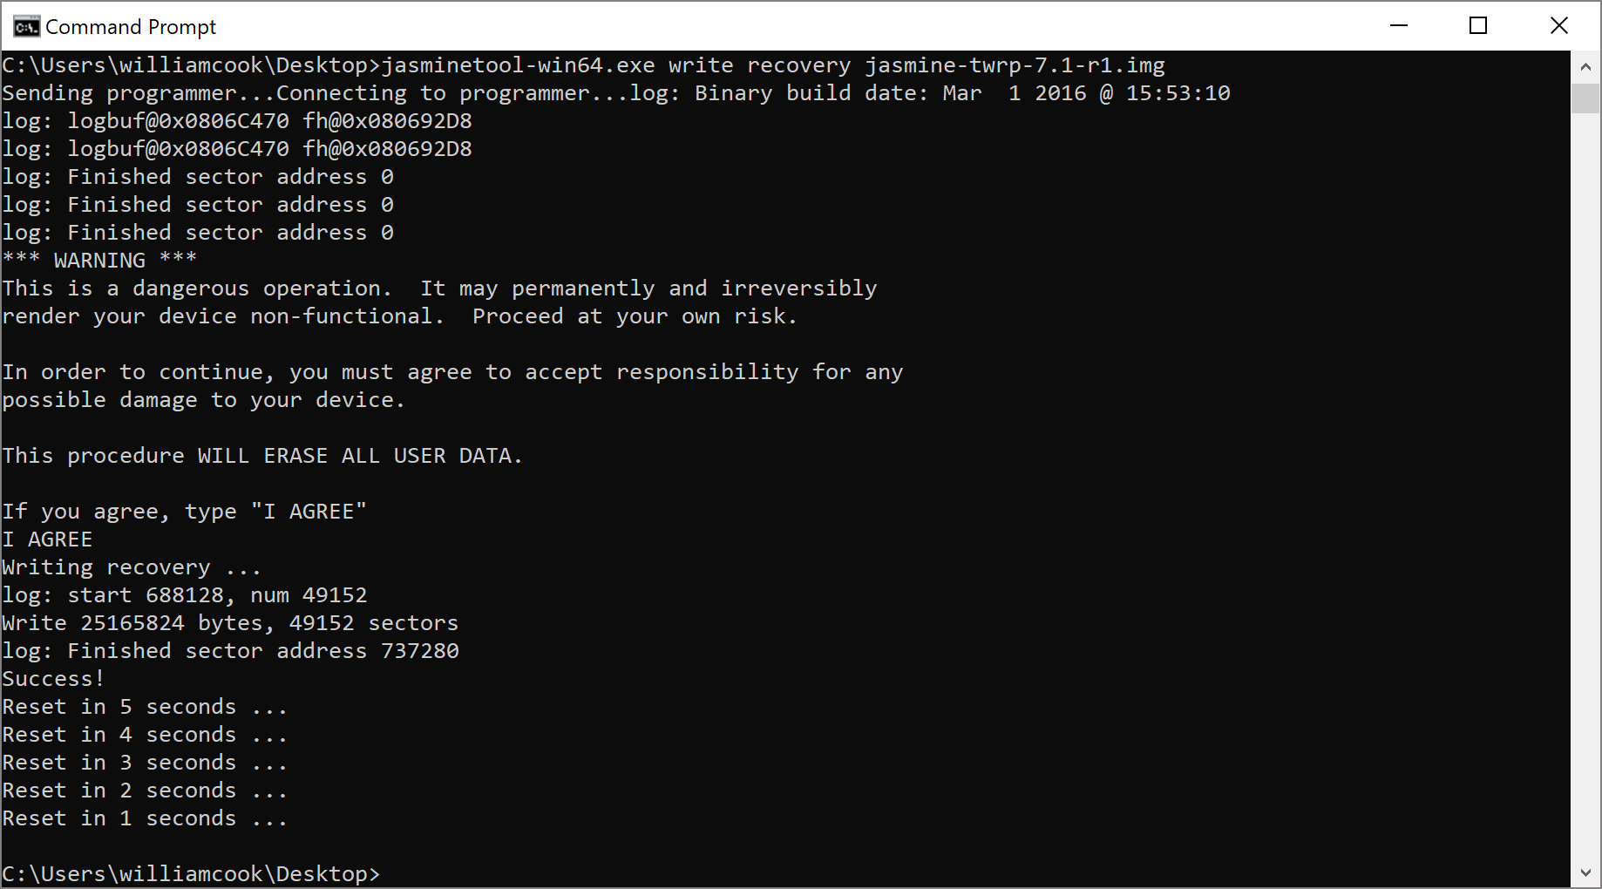

After the tablet reboots, send *adb reboot recovery* and your tablet will boot into TWRP. When you’re in TWRP, it might ask for a password, just cancel.

**Step 5.1: Install Magisk and debloat**

If you’re fine using the stock AT&T rom, but still want root, go to [this thread](https://forum.xda-developers.com/apps/magisk/official-magisk-v7-universal-systemless-t3473445) and download the latest version of Magisk. If you want to also debloat your system from the crappy AT&T applications, [grab this Magisk module](https://forum.xda-developers.com/apps/magisk/module-terminal-debloater-debloat-t3584163) too. From TWRP navigate to Advanced and click Sideload. Once you’re given the go-ahead, issue *adb sideload magisk-v15-3.zip* from your command line. It’ll install. Reboot back into recovery and push the debloater as well as below.

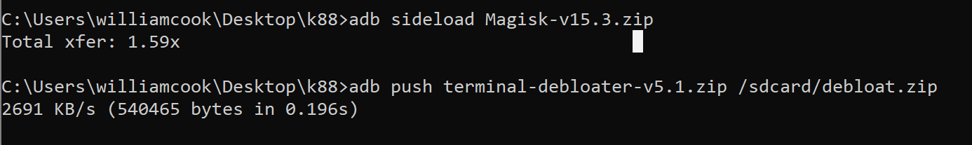

From here you can follow the debloater guide on the thread linked above. It’s not super user friendly, but hey, you chose this path :p

**Step 5.2: Download ROM and Google Apps and push to table**

Grab either LineageOS or AOKP from <http://files.nwwn.com/android/k88/> and then grab the [OpenGApps](http://opengapps.org/) package (Arm64, 71, micro should suffice). We need to push these to the sdcard. You can use the gui in Windows if you want, I just used ADB. send *adb push romofyourchoice.zip /sdcard* (you’ll see I pushed to /sdcard/download). This will take awhile and you won’t see any progress, don’t freak out. When that completes, do the same with the opengapps.zip. This will take a bit too:

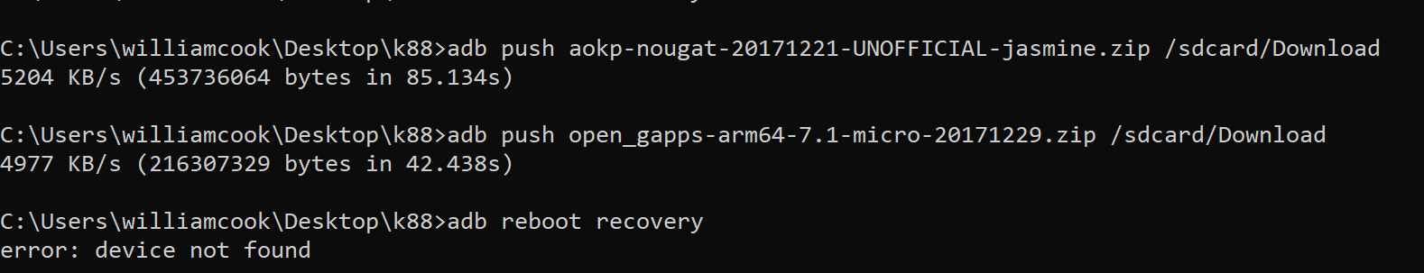

**Step 6: Flash ROM and Google apps**

Now that you’re in TWRP, you should see the screen on the left:

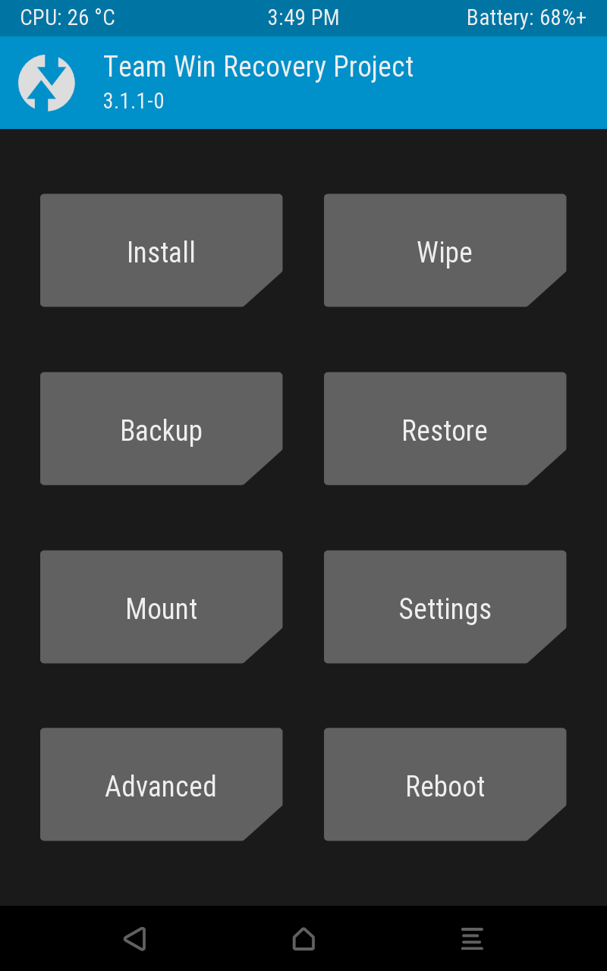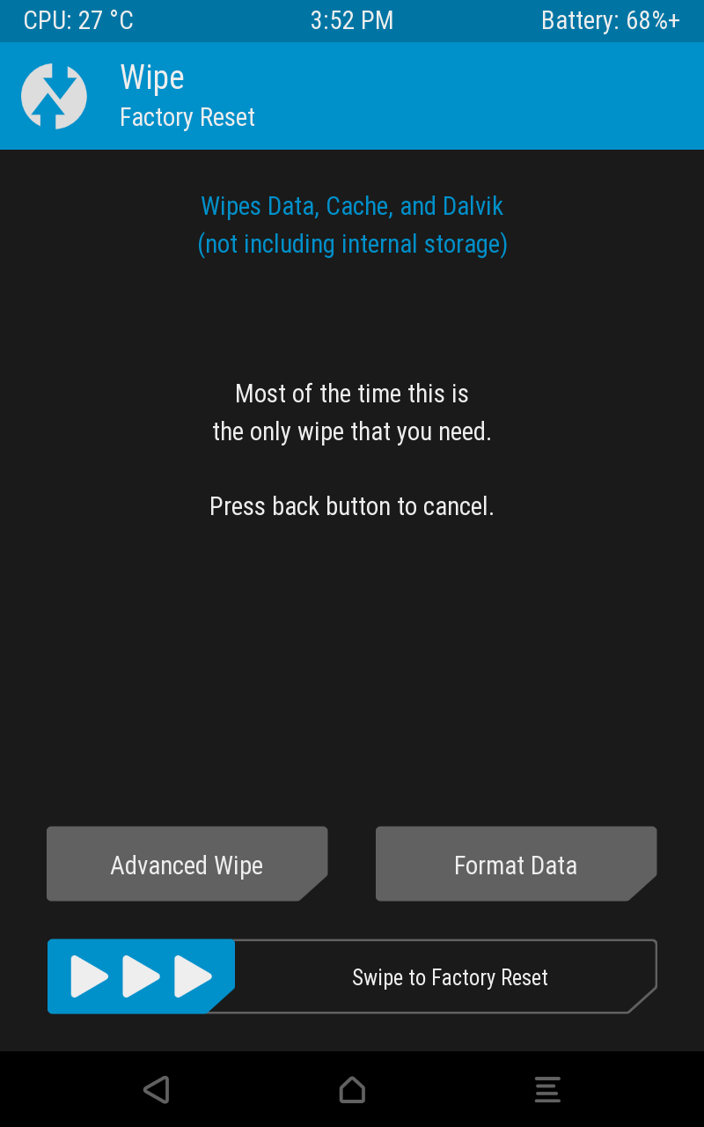

If you’re squeamish, make a backup. I won’t go over that here since I did not make one beforehand. Before we can flash anything, we need to make sure the partitions are clean. Click on “Wipe” and get to the right screen above.

The basic factory reset is plenty. Give it a swipe and let it do it’s thing. Once the device is thoroughly devoid of any system data, go back to the main menu and tap “Install”. You’re greeted with a file manager.

Navigate to the /sdcard folder we pushed our zips to. Click on your ROM zip to get to the install screen. Once you’re ready, give it a swipe to flash. Once it’s complete, reboot into your new OS and then back into recovery.

**THE ORDER YOU INSTALL IS IMPORTANT. INSTALL THE ROM FIRST. ONLY THE ROM.**

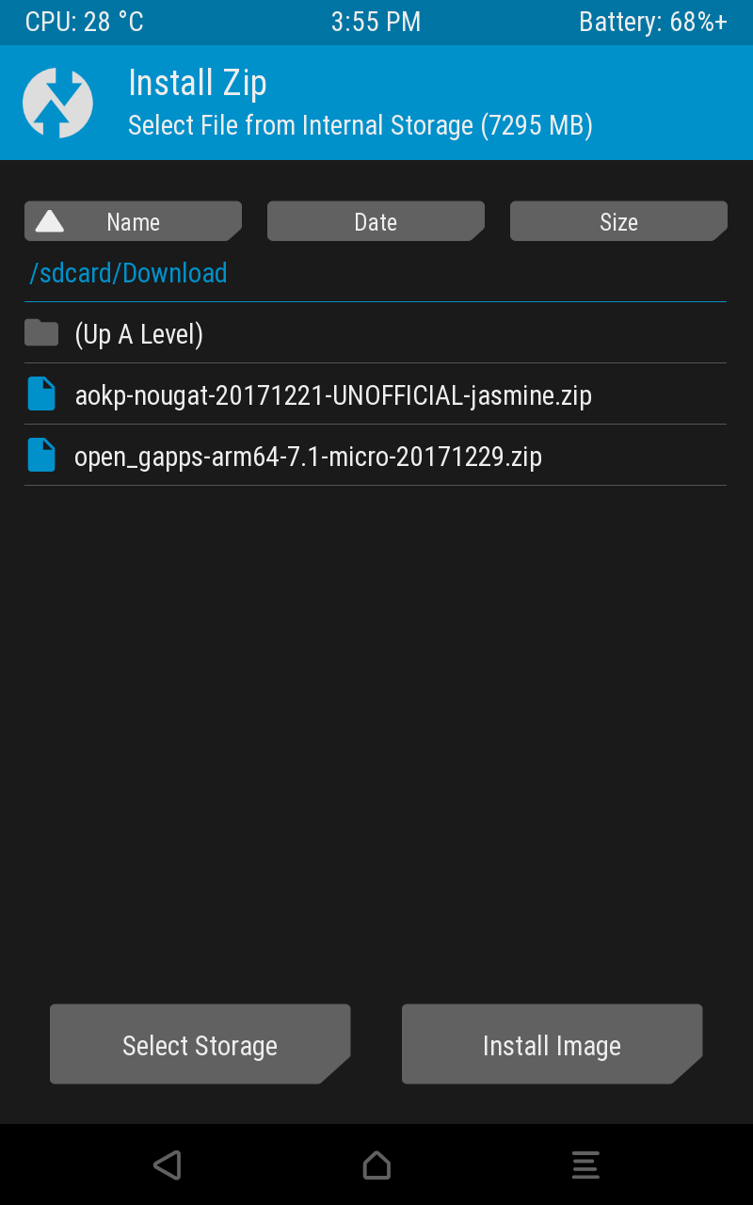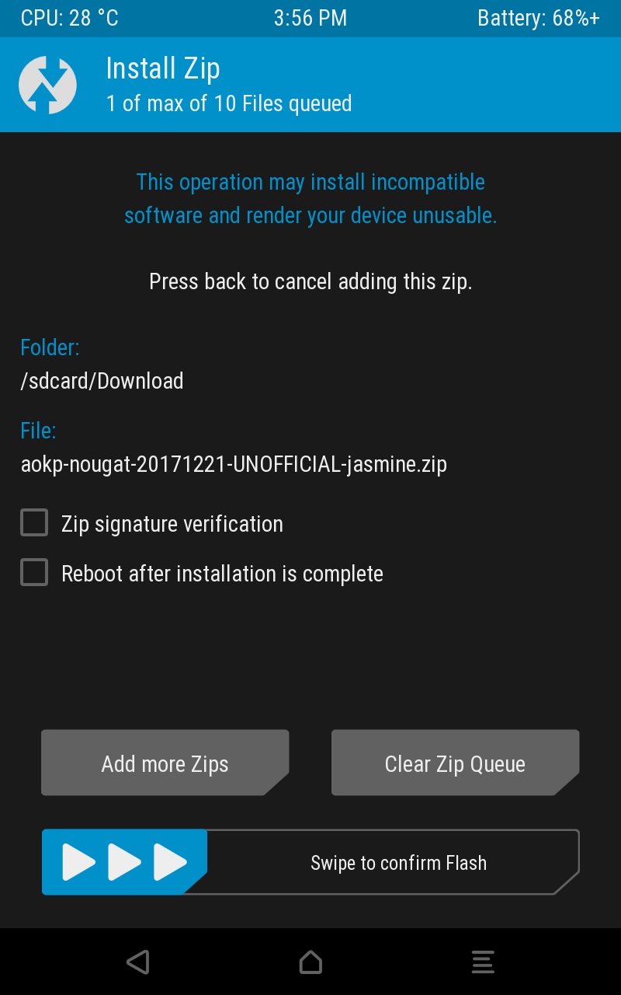

Now that you have a new OS and are once again in recovery, navigate to your OpenGAPPs package and flash it as well.

**Step 7: Enjoy rooted tablet and new OS!**

Reboot and you should be up and running. Enjoy!

**Step 7.1: Enable Cellular Functionality**

Your new ROM might not correctly detect your carrier settings. I’m on AOKP so this might be different for other ROMs. If you can’t connect to the internet right away, go to Settings -> (Wireless and Networks) More -> Cellular Networks -> Access Point Names. For AT&T, I’m using ATT Boradband.